1. **Search using ID**

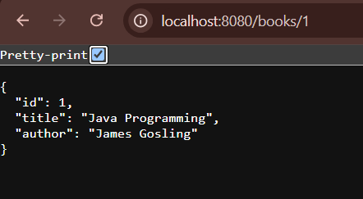

1. **Search using Author name and Title**

